

  - Fundamentals of Web Design (FWD)
  - Assignment
To make Calendar website on html

Submitted by: Jeu Machahary
Submitted to: Spandan Sir
Roll Number: 242025058
B.Tech. CSE 4th Sem (RSET)

Raw Design:
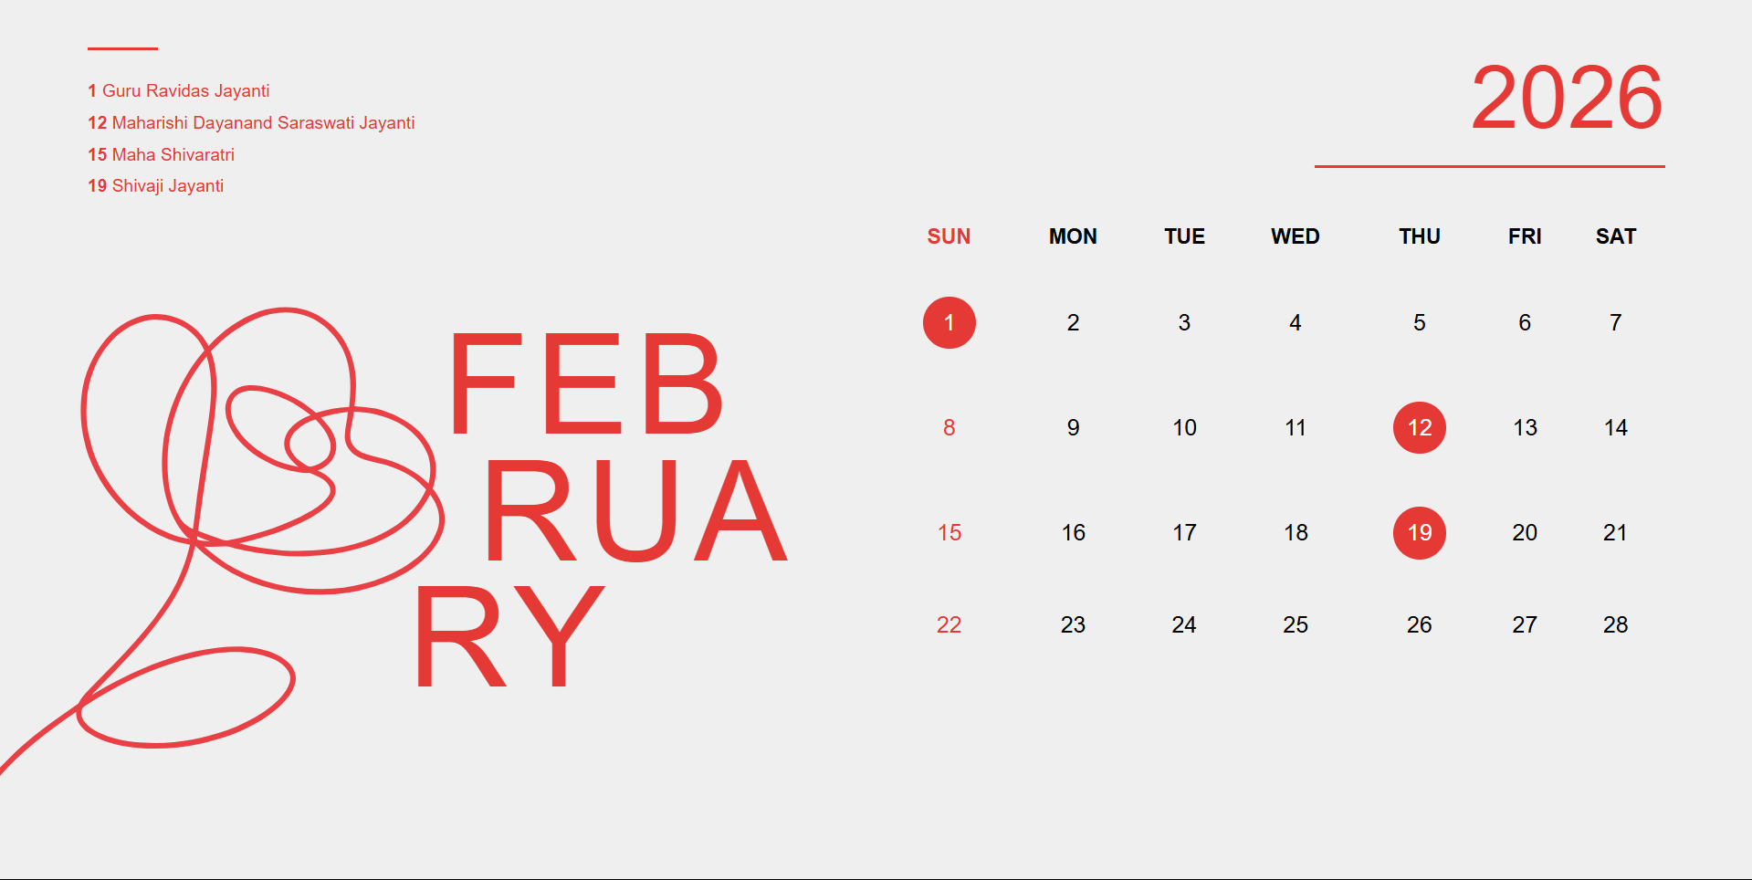

CODE:
<!DOCTYPE html>
<html lang="en">
<head>
<meta charset="UTF-8">
<meta name="viewport" content="width=device-width, initial-scale=1.0">
<title>Calendar</title>
</head>
<body style="margin: 0; padding: 0; background: #efefef; min-height: 100vh; font-family: Arial, Helvetica, sans-serif; overflow: hidden;">
<div style="width: 100%; min-height: 100vh; display: flex; padding: 6vh 5vw; position: relative; background: #efefef; box-sizing: border-box;">
<div style="width: 45%; position: relative; box-sizing: border-box;">
<div style="width: 4vw; height: 2px; background: #e53935; margin-bottom: 1.5vw;"></div>
<div style="color: #e53935; font-size: 1vw; line-height: 1.8;">
<strong style="font-weight: bold;">1</strong> Guru Ravidas Jayanti<br>
<strong style="font-weight: bold;">12</strong> Maharishi Dayanand Saraswati Jayanti<br>
<strong style="font-weight: bold;">15</strong> Maha Shivaratri<br>
<strong style="font-weight: bold;">19</strong> Shivaji Jayanti
</div>
<img src="February-image.svg" alt="February Art" style="position: absolute; bottom: -20px; left: -165px; width: 45vw; max-width: 500px; opacity: 1; transform: rotate(35deg); transform-origin: center;">
<div style="position: absolute; top: 45%; left: 45%; transform: translateY(-20%); font-size: 8vw; font-weight: 300; color: #e53935; line-height: 0.9; letter-spacing: 0.4vw;">
<span style="display: block; margin-left: 2vw;">FEB</span>
<span style="display: block; margin-left: 4vw;">RUA</span>
<span style="display: block; margin-left: 0;">RY</span>
</div>
</div>
<div style="width: 55%; padding-left: 5vw; display: flex; flex-direction: column; box-sizing: border-box;">
<div style="text-align: right; font-size: 5vw; font-weight: 300; color: #e53935;">2026</div>
<div style="width: 20vw; height: 2px; background: #e53935; margin-left: auto; margin-top: 1vw; margin-bottom: 4vh;"></div>
<table style="width: 100%; border-collapse: collapse; text-align: center;">
<thead>
<tr>
<th style="font-size: 1.2vw; padding: 1.2vw 0; font-weight: bold; color: #e53935;">SUN</th>
<th style="font-size: 1.2vw; padding: 1.2vw 0; font-weight: bold;">MON</th>
<th style="font-size: 1.2vw; padding: 1.2vw 0; font-weight: bold;">TUE</th>
<th style="font-size: 1.2vw; padding: 1.2vw 0; font-weight: bold;">WED</th>
<th style="font-size: 1.2vw; padding: 1.2vw 0; font-weight: bold;">THU</th>
<th style="font-size: 1.2vw; padding: 1.2vw 0; font-weight: bold;">FRI</th>
<th style="font-size: 1.2vw; padding: 1.2vw 0; font-weight: bold;">SAT</th>
</tr>
</thead>
<tbody>
<tr>
<td style="font-size: 1.3vw; padding: 1.5vw 0;">
<span style="display: inline-flex; align-items: center; justify-content: center; width: 3vw; height: 3vw; border-radius: 50%; background: #e53935; color: white;">1</span>
</td>
<td style="font-size: 1.3vw; padding: 1.5vw 0;">2</td>
<td style="font-size: 1.3vw; padding: 1.5vw 0;">3</td>
<td style="font-size: 1.3vw; padding: 1.5vw 0;">4</td>
<td style="font-size: 1.3vw; padding: 1.5vw 0;">5</td>
<td style="font-size: 1.3vw; padding: 1.5vw 0;">6</td>
<td style="font-size: 1.3vw; padding: 1.5vw 0;">7</td>
</tr>
<tr>
<td style="font-size: 1.3vw; padding: 1.5vw 0; color: #e53935;">8</td>
<td style="font-size: 1.3vw; padding: 1.5vw 0;">9</td>
<td style="font-size: 1.3vw; padding: 1.5vw 0;">10</td>
<td style="font-size: 1.3vw; padding: 1.5vw 0;">11</td>
<td style="font-size: 1.3vw; padding: 1.5vw 0;">
<span style="display: inline-flex; align-items: center; justify-content: center; width: 3vw; height: 3vw; border-radius: 50%; background: #e53935; color: white;">12</span>
</td>
<td style="font-size: 1.3vw; padding: 1.5vw 0;">13</td>
<td style="font-size: 1.3vw; padding: 1.5vw 0;">14</td>
</tr>
<tr>
<td style="font-size: 1.3vw; padding: 1.5vw 0; color: #e53935;">15</td>
<td style="font-size: 1.3vw; padding: 1.5vw 0;">16</td>
<td style="font-size: 1.3vw; padding: 1.5vw 0;">17</td>
<td style="font-size: 1.3vw; padding: 1.5vw 0;">18</td>
<td style="font-size: 1.3vw; padding: 1.5vw 0;">
<span style="display: inline-flex; align-items: center; justify-content: center; width: 3vw; height: 3vw; border-radius: 50%; background: #e53935; color: white;">19</span>
</td>
<td style="font-size: 1.3vw; padding: 1.5vw 0;">20</td>
<td style="font-size: 1.3vw; padding: 1.5vw 0;">21</td>
</tr>
<tr>
<td style="font-size: 1.3vw; padding: 1.5vw 0; color: #e53935;">22</td>
<td style="font-size: 1.3vw; padding: 1.5vw 0;">23</td>
<td style="font-size: 1.3vw; padding: 1.5vw 0;">24</td>
<td style="font-size: 1.3vw; padding: 1.5vw 0;">25</td>
<td style="font-size: 1.3vw; padding: 1.5vw 0;">26</td>
<td style="font-size: 1.3vw; padding: 1.5vw 0;">27</td>
<td style="font-size: 1.3vw; padding: 1.5vw 0;">28</td>
</tr>
</tbody>
</table>
</div>
</div>
</body>
</html>

